Trade-offs in Textual Data Extraction Methodologies: A Case Study of Army Career Progression Document Data
Nakshatra Yalagach and Sara Shallenberger

Introduction
For the data scientist, coercing information from an unstructured text format to a useable configuration for analysis can be a daunting task. For this reason, computer and data scientists have developed what seems like an overwhelming number of solutions to this problem, each of which requires unique considerations before being applied to data. We explored several of these methods as Data Science for the Public Good (DSPG) interns for the University of Virginia’s Biocomplexity Institute for Social and Decision Analytics Decision on a project sponsored by the Army Research Institute for the Behavioral and Social Sciences.
Our goal for the first phase of the project was to explore methodologies for extracting data from PDF files and conduct exploratory analysis on this textual information. The results will be used in the following stages of our project, which will analyze the career progression of Soldiers across Army branches and contribute information pertaining to Large Language Models (LLMs) to open source-repositories.

Data
The textual data in the project was sourced from officer development manuals for 14 Army operations and information dominance branches. We targeted three main data attributes in our extraction:
- Rank (Lieutenant, Captain, etc.)
- Assignment (an officer’s position or job)
- Type of Assignment
  - Key Developmental or Broadening
  - Key Developmental assignments are critical for officer promotion and overall career advancement compared to Broadening assignments

Challenges
One of the major challenges with extracting text from the officer development manuals was inconsistent documentation. Each document was written with unique headers, formatting, bulleting, and language describing assignments and their types. As depicted in the below figures data is present in different structures across documents.
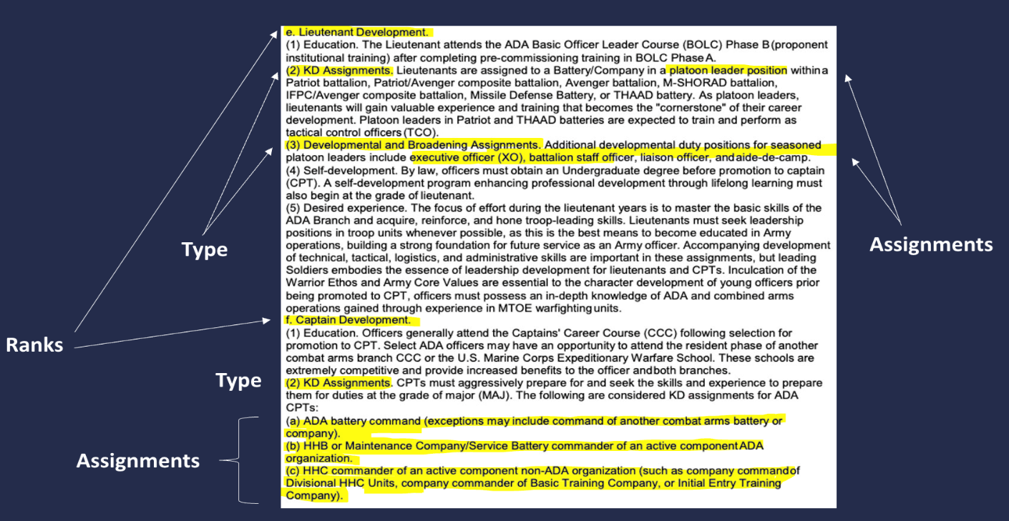
Fig 1: Sample Document A – Air Defense Artillery

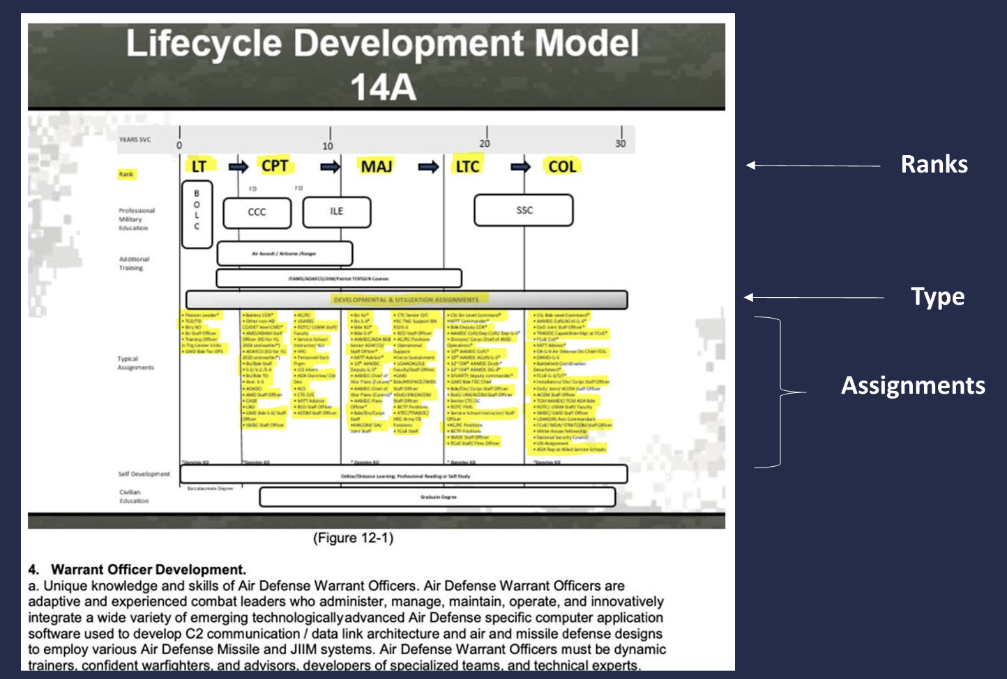
Fig 2: Sample Document A – Air Defense Artillery

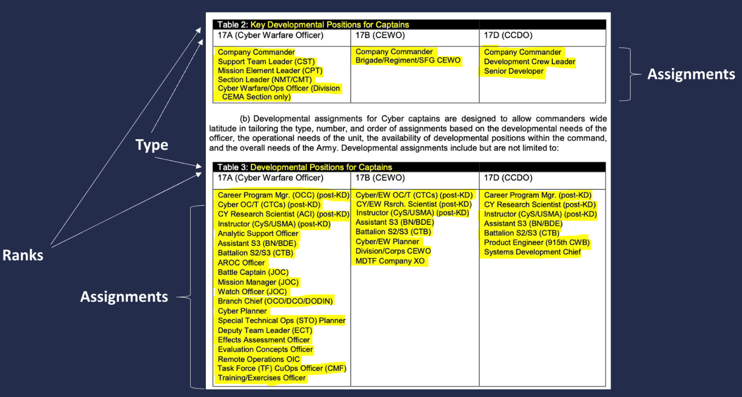Fig 3: Sample Document B: Cyber Branch

Figure 1 presents a snapshot of the Air Artillery Document, displaying the assignments arranged in alphabetical order. Additionally, Figure 2 illustrates the assignment information within the same document in image format. In the case of the Cyber Branch document, the data is presented in a tabular format, as depicted in Figure 3. Due to these inconsistencies, it was necessary to identify a robust extraction approach that consistently yielded accurate results across all documents.
Methods
We extensively examined a range of text extraction techniques and provide comprehensive assessments of the advantages and disadvantages associated with each technique. By documenting these findings, we aim to facilitate future studies, enabling them to leverage the knowledge gained from our research. The advantages and disadvantages of each method can be assessed with the requirements of the project to enable the selection of the most suitable approach.
Method 1 – Image Upscaler
Since the document contained an image encompassing ranks, assignments, and their types, we deemed it advantageous to extract the data from the image. However, the image itself was of low quality. Consequently, our initial approach involved upscaling the image to enhance its resolution. We experimented with various combinations, including 200x and 400x upscaling.
Advantages:
Image upscaling offers several advantages, including improved resolution, reduced noise, and time efficiency. By enhancing the resolution of images, upscaling techniques contribute to a clearer and more detailed visual representation. Additionally, the reduction of noise artifacts in the upscaled images enhances their overall quality, while the time efficiency of the upscaling process allows for faster and more streamlined image enhancement workflows.
Disadvantages:
Image upscaling techniques can present drawbacks including the potential for distorted results, illegible output, and only partial improvement in image quality. These limitations can arise due to the inherent challenges in extrapolating information to a higher resolution. Furthermore, while some improvement in quality can be achieved, the upscaling process may not fully address all the nuances and details of the original image.
Conclusion:
While upscaling did improve the image quality to some extent, the extracted assignments remained difficult to read and comprehend. Therefore, we transitioned to employing text extraction techniques utilizing ChatGPT to overcome this challenge.
Method 2 - ChatGPT
The methodology employed for text extraction using ChatGPT involved providing a prompt along with the relevant section of the document containing the assignments. Multiple prompts were testedto identify the prompt that yielded the most accurate results. However, a challenge arose as slight rearrangements of the words in the prompt led to different outputs from GPT. Furthermore, another obstacle emerged when attempting to extract data for "Lieutenant Colonel" and "Colonel" assignments, as GPT failed to retrieve the desired information.
Advantages:
ChatGPT offers several advantages, including its ease and speed of implementation, the ability to reuse prompts, and its effectiveness in extracting data across various test documents. This makes ChatGPT a convenient and efficient tool for text extraction tasks, ensuring generally consistent and reliable outcomes across different formats of the document being analyzed.
Disadvantages:
It does have certain limitations, such as being sensitive to user input, potentially generating different outputs for identical prompts, and exhibiting less precision in extracting assignments. These drawbacks highlight the need for careful and specific input formulation to achieve desired results, while acknowledging the inherent challenges of maintaining consistency and precision in the extraction process.
Conclusion:
Due to the variability in responses across use of the same prompts and overall inaccuracy of the results, the decision was made to transition to a Regex-based approach.
Method 3 - Regular Expressions
The final method we explored to extract data from the Army documents was the use of regular expressions, which match strings of interest in the text. Unlike the ChatGPT method, writing regular expressions took more time on the part of the scientist. Since each branch used a unique formatting style, our regular expressions had to be modified for each document. A basic function using regular expressions would iterate through each character in the document and match to the sections following bullet points.
Advantages and Disadvantages:
While this highly supervised extraction method was more time-intensive, it also allowed for the most precise extraction of assignments of the three methods explored and allowed for better control of the output format.
Chosen Method and Summary
We chose the regular expression technique as the final method to extract data from documents. This method was the best fit for our set of data because we had a small number of documents (14) and favored reproducible results that captured the most individual assignments and their types over the more variable outputs produced by ChatGPT. If our dataset was much larger, this method would not be ideal because of how time intensive it was to make edits to the code for each document we needed to analyze. However, this method was satisfactory for completing our goals during this phase of the project.

The data extraction phase of the Army Research Institute project demonstrated that there is no ideal way to extract data from documents. At the end of the day, it comes down to you, the scientist, to choose a solution that best fits your data, timeframe, reproducibility, and analysis goals.

